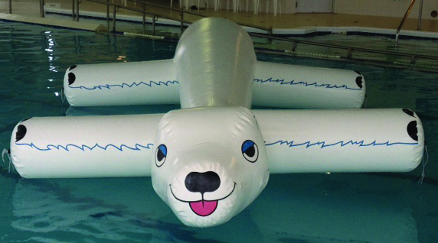  Name  is turning 10!  Anything else you want to say here…. | Join us for the party!  Snorkel the Giant Inflatable Polar Bear  [Date and Time]  11905 U.S. 31 North, Charlevoix  RSVP - [Telephone]

Name  is turning 10!  Anything else you want to say here…. | Join us for the party!  Snorkel the Giant Inflatable Polar Bear  [Date and Time]  11905 U.S. 31 North, Charlevoix  RSVP - [Telephone]

